Introducing Teams  
An organizational hub for improved communication and collaboration

[**Microsoft Teams**](https://office365.utexas.edu/teams) **is a fundamental part of the** [**Microsoft 365 suite provided by The University of Texas at Austin**](https://office365.utexas.edu/teams) **to all** [**staff**](https://office365.utexas.edu/staff-and-microsoft-365)**,** [**faculty**](https://office365.utexas.edu/faculty-and-microsoft-365)**, and** [**students**](https://office365.utexas.edu/students-and-microsoft-365)**.**



Looking to get started? Come or call in to the new [Instructional Technologies Office Hours](https://intranet.dellmed.utexas.edu/event/767918/2024/06/25).  
  
Want to talk more about Microsoft Teams and abilities or have a quick question? Book [a Quick Meet](https://outlook.office.com/bookings/newmeetingtypecompose?src=calendar) with Dell Med Instructional Designer,   
Michelle Read, Ph.D.

Want training on how to use Teams? [Let us know](mailto:michelle.read@austin.utexas.edu?subject=Interested%20in%20Teams%20training)!

Finding integrated apps for Teams is easy (see the

screenshot below) and can be searched by categories, industry, etc. and filtered by availability, pricing, and features.

**\*Note** – Some apps are “ready to add”, while others allow one to request approval.

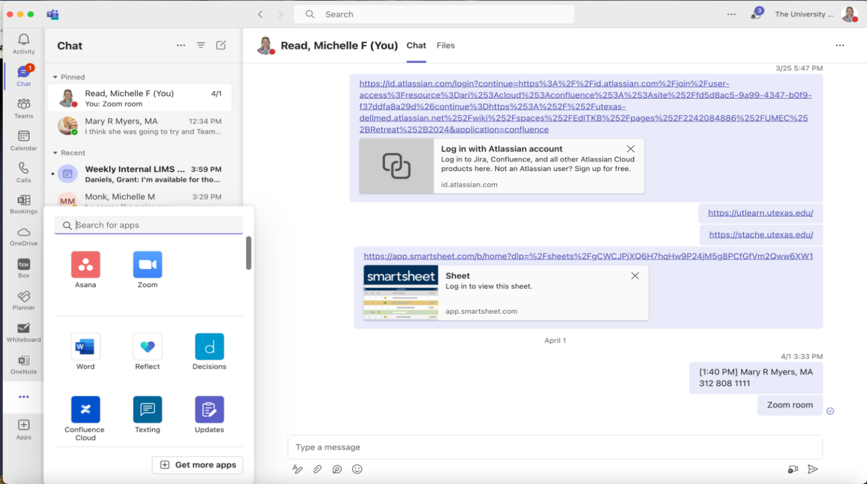

User defined and sorted apps.

and arranged apps.

Some apps display most recent or pinned reference items.

Activity/Engagement Panel

Access more of your installed apps or find others to add!