Changing Device Settings in Zoom & Teams

Auditorium & Labs

In the auditorium and labs, if you need to video-conference through the system, you may find that you need to change device settings in the video-conferencing tool you are using.

# Zoom

To do this in Zoom, you will need to go to the Settings window and click and select the appropriate camera and mic/speaker system. You can do this outside a meeting (A) by clicking under Settings or from inside (B) a meeting by clicking the arrows next to “Join Audio” and “Start Camera”

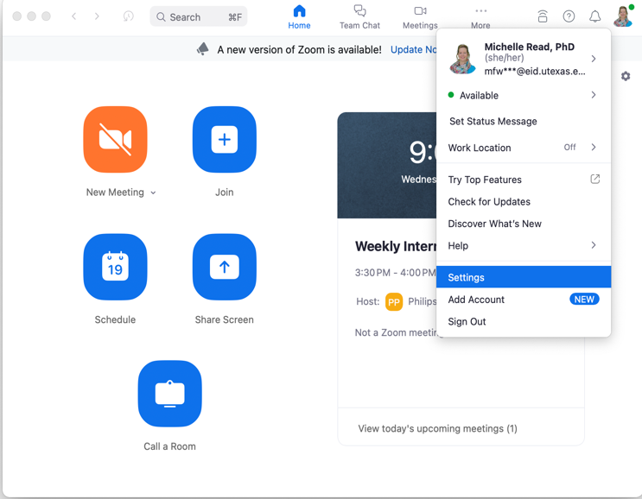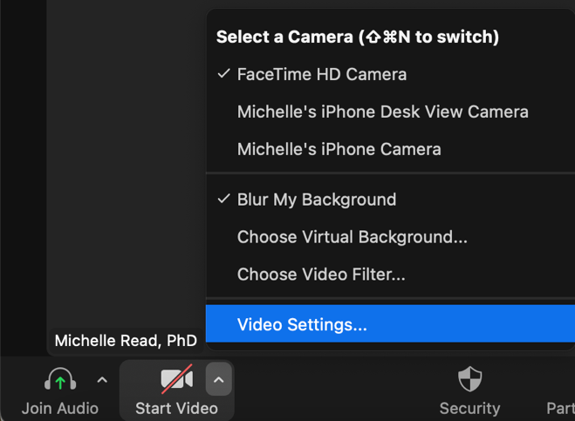

Regardless, once your laptop is physically connected to the system, it should add the system devices to the list of options. Choose the devices appropriate for your location.

!Important: Do not forget to switch the source to your laptop on the Crestron Control Panel to see on the room displays.

# Teams

If you are joining a meeting with a link, you’ll find the device settings on the pop up that shows just before entering the virtual room. Choose the gear to open the Device Settings panel (1), then select the system speaker (2) and mic (3), and finally, select the system camera (4). You should see a preview if you turn the camera on (5). Once you have changed the speaker and mic to the room system devices, you can test volume (6).

If you are making a cold call from within Teams, you will enter the room first before changing the device settings. If your laptop is physically connected to the system, it should add the system devices to the list of options. Choose the devices appropriate for your location.

!Important: Do not forget to switch the source to your laptop on the Crestron Control Panel to see on the room displays.

# Your Laptop

Sometimes these options do not show up in Zoom or Teams automatically even if they are plugged into the system. Sometimes you have to change or acknowledge the room system devices on your laptop overall and then make the changes in Zoom or Teams.

**\*Note -** If you do not see the room system devices listed on your laptop’s device general settings, you should first check the connection between the laptop and room system and lastly, you may need to restart your computer.

## Mac

1. Under the Apple icon, go to “System Settings” and select “Sound”. Under “Output & Input” select the appropriate room system device for each tab. In the screenshot below, you’ll notice that no room system devices are listed. See Note.

2. In the same window, click on “Displays” and select the room system device by clicking on the “+” icon at the top of the window.

## Windows

1. Go to *Settings*
2. A screenshot of a computer

   Description automatically generatedChoose “*System>Sound*” and select the room system device for both your speakers (1) and microphone (2). If you do not see them listed, then check your physical cable connecting your laptop to the room system, and/or restart your computer. ***Do not select “Add Device”.***

1. Choose “*System>Bluetooth & Devices>Camera*” and select the room system device. If you do not see it listed, then check your physical cable connecting your laptop to the room system, and/or restart your computer. ***Do not select “Search for cameras”.***