Canvas Tip: Assigning Modules or Pages to Individuals and Sections
  - Not available until July 22, 2024

A much discussed and requested Canvas feature will be available July 22, 2024 at The University of Texas Austin. This feature allows instructors to assign both pages and entire modules to individuals or sections of students.
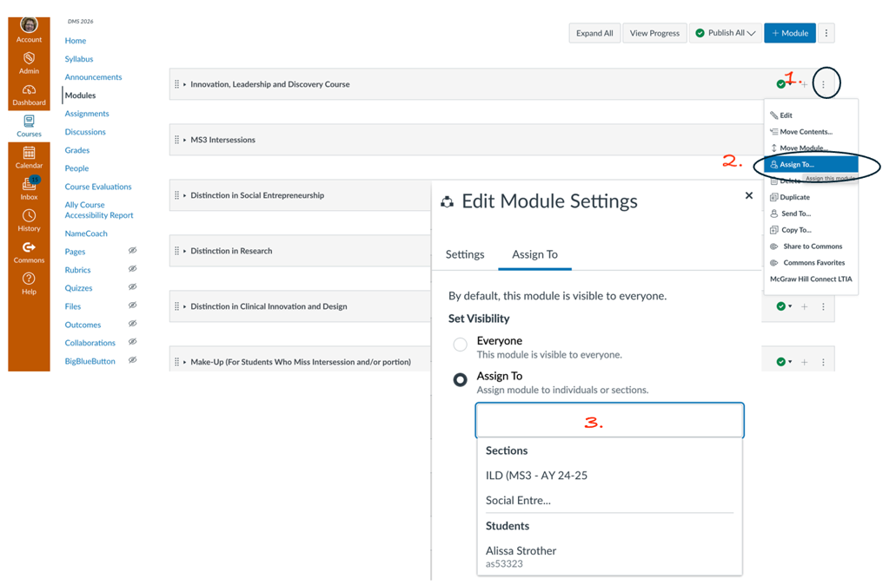
Module Assignments –
Click on the ellipsis to the right of the module and click “Assign To…”. A pop up window appears that allows you select “Everyone” or “Assign To” and pulls up a list of existing sections and individual students to choose from.

*Note – For both Modules & Pages, this only works for assignment sections, if sections have been created previously.
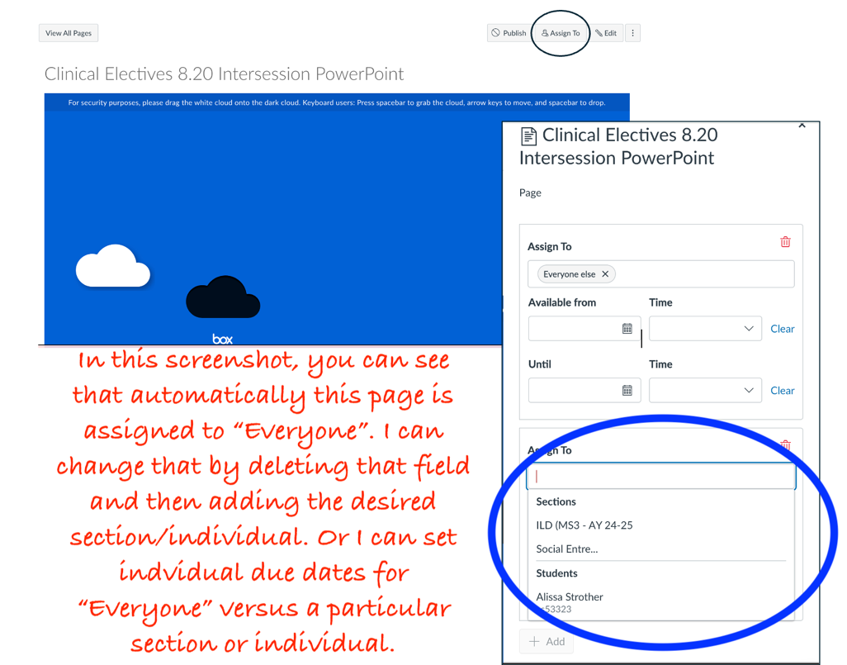
Page Assignments –
Follow the exact procedure above (clicking on the ellipsis next to the page name) OR open the page and click on the “Assign To” button.

