Canvas Tips: Using CidiLabs’s DesignPlus and Multi-tool to Build!

# Definitions

## DesignPlus

DesignPlus is a CidiLabs tools installed in our Canvas account. DesignPlus helps designers to create easily navigable and aesthetically pleasing spaces for students, responsive content (adjusts to screen size) and interactive navigation so students can see just what they need to see without all the extra stuff in the way. DesignPlus also includes a *Quick Check* feature that disallows students moving forward until they’ve answered the question correctly. CidiLabs recently released a new version of DesignPlus with a much easier user interface for designers and a couple new functional elements. The version currently in place is now referred to as “Legacy” tools and is currently planned to be completely decommissioned by CidiLabs in December 2024. It’s important to know this information because *CidiLabs warns that content created under the Legacy tools may not survive a simple switch to the new tools.*

*It is important to know that many of these tools can be turned on/off by clicking on the settings (gears) icon.*

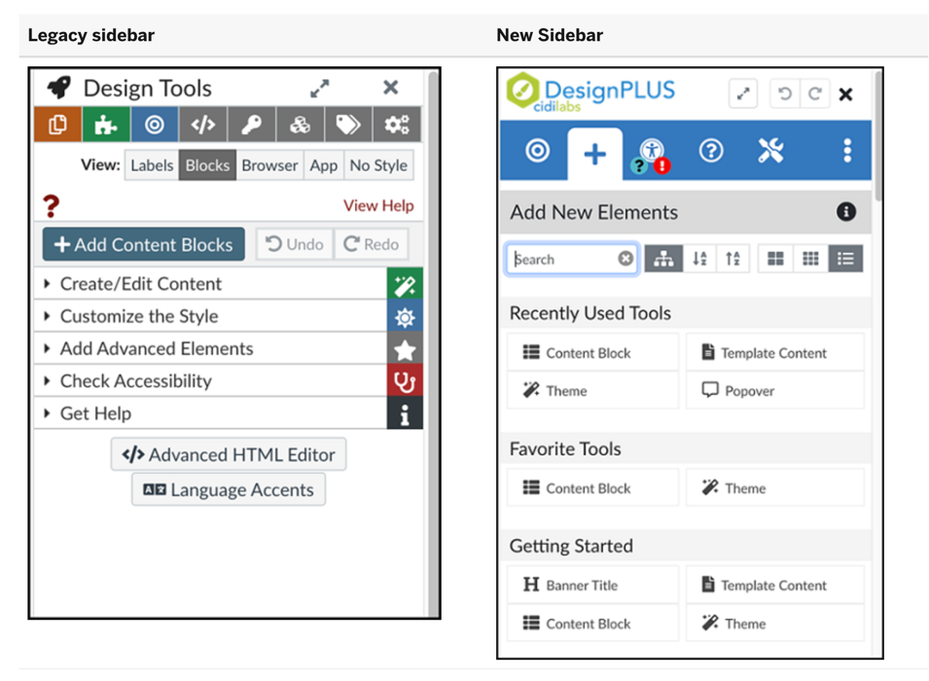

## Multi-Tool

The CidiLabs Multi-Tool expands the DesignPlus tools further by allowing the course designer to easily create templates (a) to use for creating a lesson content page, an assignment page, a discussion page, (c) etc. You can also set up module templates (b) so students will always see the exact same structure regardless of which module they are in. Additionally, you can create announcements in advanced with delayed due dates and quickly modify due dates (a).

## Working with the Legacy Sidebar

Knowing that our access to the new sidebar is minimally 2-3 months away, this section will highlight the possibilities within the legacy tools. *Keep in mind, anything you create with the legacy tools will need to be switched to the new tools by December 2024.*

The legacy sidebar uses an accordion style navigation to get to various tools. The whole window can be enlarged (1) and shortcuts (2) to the accordioned tools (3) are provided in the top row of the sidebar. Note the view options (4) that allow you to see the elements of the pages as labels and/or blocks, in context (browser or mobile application) or with no style <CSS> applied. Finally, there are help buttons (5) at the top to allow designers/editors to review the meaning of the view buttons.

*Extra tip: If you want to make sure your content looks the way you want in mobile view, edit in mobile view.*

The *+Add Content Blocks* (6) button quickly allows the designer/editor to add any number of dividers (or blocks) to their page. Several institutional block templates have been provided, but you can also create and label your own at the top. When the +Add Content Blocks button is clicked, the first tool accordion (7) is also opened, displaying seven sub-categories, the first of which, allows one to use other templates, such as one you may have created in Multi-Tool, copy a page, copy other institutional templates, if they exist, or copy content by url. In this section, you can also rearrange and add even more blocks (8), choose a theme for your page (9), customize the banner text (10), select a banner image (11), add/edit navigation blocks (12), like site shortcuts, and quickly add course content links (13).

In the *Customize the Style* (14) top tier, you can select a specific element on your page and edit their size, edges and borders, colors, etc. The options change based on what element you have selected. The Add Advanced Elements (15) section is the place to add fun or more advanced navigation functionality to your site – these will be discussed below.

Finally, you will also find *Check Accessibility* (16) and *Get Help* (17) sections. The *Check Accessibility* section does a great job of checking for missing Alt Text on the page, order of headers, external links, etc. and mostly allows that to be fixed directly within DesignPlus. It is suggested you attend to any issues found there after you have edited content before publishing. The *Get Help* section provides many resources for further help using the tool.

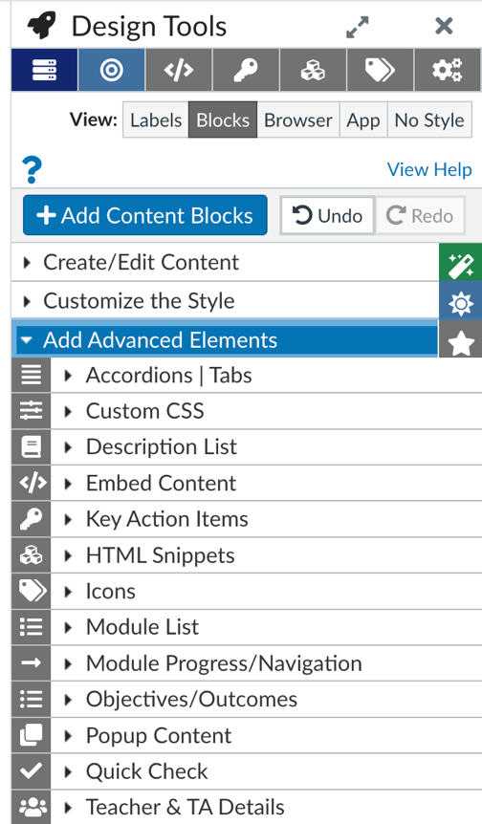

## The +Advanced Element Section Defined

When you open the *Advanced Elements* section, thirteen additional sub sections open. Each may have additional elements inside them. These are mostly “wizard” like, meaning all you must do is provide the content and DesignPlus formats it and inserts it to the page.

1. *Accordions | Tabs* – you can add accordions, expanders or tabs as their own block or at the cursor and create/rearrange/delete/rename, etc. the content divisions in the DesignPlus section. Expanders are like Accordions but are collapsible expander by expander.
2. *Custom CSS* – If you file a separate CSS file in the Files section of the course and then select yes to using it, the page will render based on the CSS in your file.
3. *Description List* – you can use these to create a FAQ or vocabulary list, etc.
4. *Embed Content* – embed iframe codes.
5. *Key Action Items* – notes only seen by other editors.
6. *HTML Snippets* – a set of institutional (if they exist) and DesignPlus code that can be used to add images with captions, various horizontal lines, columns, blockquotes, etc.
7. *Icons* – highlights the icons already used in the course for quick selection.
8. *Module list* – Provides a full or partial list of course modules with or without content, some with check off features.
9. *Module Progress/Navigation* – These are helpful for students as they can jump around the pages within the module without relying on the Previous/Next button.
10. *Objectives/Outcomes* – if previously added by admin.
11. *Popup Content* – You can choose from three different styles of content.
12. *Quick Check* – Create a question to inspire thinking or reflection. You can make this mandatory so that participants have to answer before the Next button shows. You can provide feedback, but these are not graded, and you’ll never see what they selected.
13. *Teacher & TA Details* – add details you want viewers to see. Everything can be added here except for the instructor image. DesignPlus takes the image from the Canvas Account bio page.