Canvas Tip

Creating a Text Descriptor Grade Only for Students

# Setup:

1. Go to the Course Settings page, select “Enable Course grading scheme” and click on

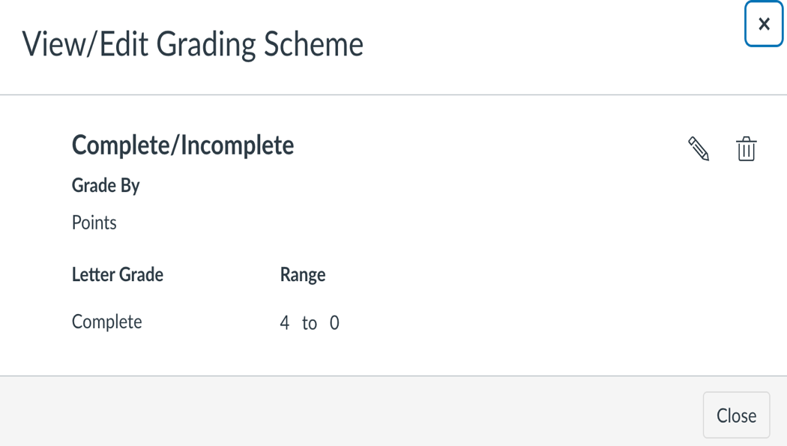

Course Grading Scheme

* 1. Click “Manage All Grading Schemes”.
  2. Select “Complete/Incomplete “, or if not available, create a “New Grading Scheme”. Recreate the Complete/Incomplete grading scheme as follows:
     1. Name – Complete/Incomplete
     2. Grade by – Points
     3. Letter Grade (text) – Complete
        1. Range – 4 to 0.9
        2. Click “+” to add another.
        3. Letter Grade (text) – Pending or Incomplete*
        4. Range – Leave this value empty.
     4. Save

1. Restrict students from seeing quantitative data under Course Settings.

**\*Note:** This can only be turned on with the grade scheme enabled

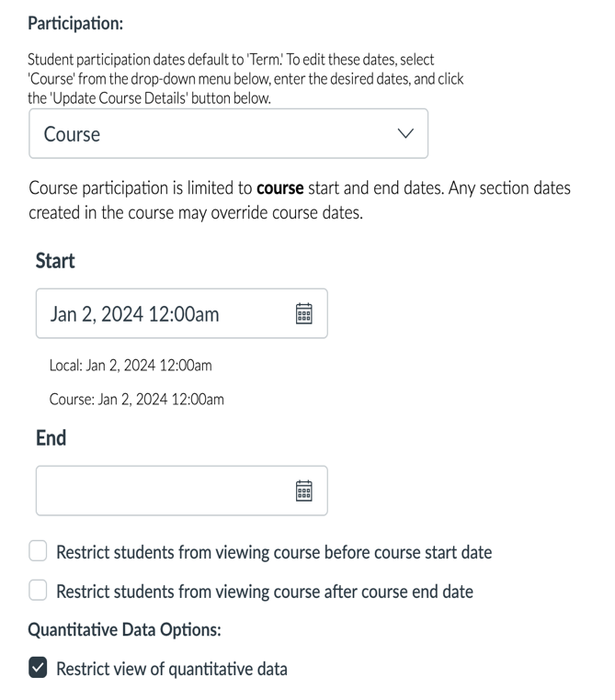

Restrict view of quantitative data found under Course Settings.

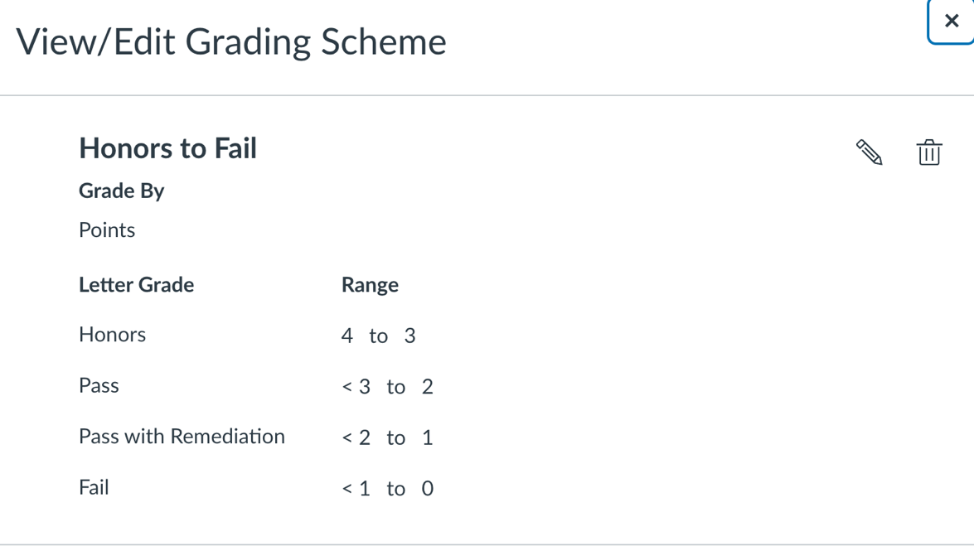

Grading Scheme –Final Grade Assignment

1. Create a Final Grade in Assignments with following settings:
   1. Title – Final Grade
   2. Description -- nothing needed
   3. Points – 4
   4. Group – leave at “Assignments”
   5. Display Grade as – “Letter Grade”
      1. Choose Honors to Fail or, if unavailable, create a new scheme under “Manage All Grading Schemes” as follows (see screenshot labeled “Grading Scheme-Final Grade Assignment” above)):
         1. Letter Grade name – Honors; range – 4 to 3
         2. Letter Grade name – Pass, range – 3 to 2
         3. Letter Grade name – Pass with Remediation, range – 2 to 1.
         4. Letter Grade name – Fail, range 1 to 0
         5. Publish the Assignment.
         6. Hide the Assignments tab and do not link to it from any other page.
   6. Instructors can provide final grades directly through the Gradebook in either the traditional or individual student views.
   7. Notes can be added to either the traditional or individual views of the Gradebook to provide context that are not seen by the student.   
      A screenshot of a computer

      Description automatically generated

*Instructor’s view of Traditional Gradebook with Notes added.*

Students will see:

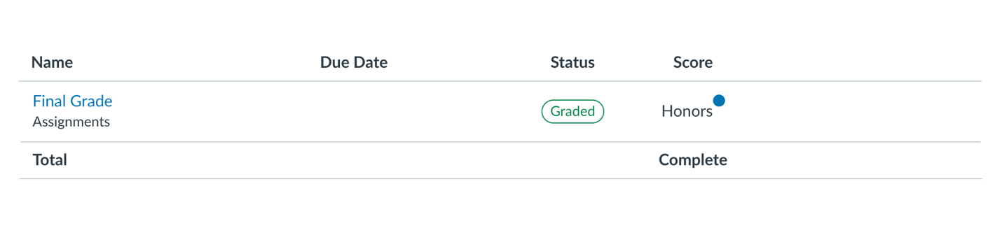

Student View of Final Grade

# Notes:

1. These grades will not transfer to the registrar since this is not an official grading scheme at the university level.
2. Individual view of grades displays differently to students if no grade was ever applied (Incomplete) vs. if a grade was applied and then deleted until they have a new grade applied; In other words, once a grade is applied, even if it is later deleted and left blank, the total will remain “Completed”.   
     
   Let’s say we change DellMed Guestone’s grade from “Honors” to an empty grade.

DellMed Guestone with Removed Grade as Seen from the Instructor’s Traditional Gradebook View.

His assignment status goes from Graded back to Not Submitted, but his Total still says “Complete”, and his Score now says “Fail” despite it just being an empty grade.

DellMed Guestone's View with previous Honors grade removed and not replaced.

By comparison, the following image shows DellMed Guesttwo’s gradebook before any grade was applied at all.  
  
# Unfortunately, in the instructor’s view of the tradition gradebook, both scenarios (i.e., never entered, entered but deleted) show the same way.

# Additional suggestions:

1. Make sure the Final Assessment grades are not “automatically” posted. You can post them all at once when you are done grading, or you can select to manually post for those who are graded.  
     
   A screenshot of a student application

   Description automatically generated

Grade “Muted”

Student View of Gradebook When Grades have been submitted, but not released.

1. !!! Hide the gradebook tab until you are ready for students to see their Final Grade.

# FAQs:

1. **Can we hide the total row altogether?** No.
2. **Can we hide the status information?** No; However, by leaving a comment on the individual gradebook, we can change the status from “Not submitted” to “Graded”. Alternatively, tell students to ignore the status label. <Someone with the related permissions may be able to make custom status labels>
3. **Why do we have to have an Assignment called Final Grade?** Because Canvas works on a point (or percentage of points) system to create a total grade, the system must be given points to do so. By going through this 3-step process and hiding the Assignment tab and Assignment from the students, they will never have access to it.
4. **Why do we publish the Assignment if we are hiding it?** Canvas only uses published assignments for calculating totals. Without publishing, the system throws an error.
5. **Why do we need to use a complete/incomplete grading scheme?** Remember the problem when one grades and then removes the grade and how the student view displays “Complete” despite the grade being removed? This holds true in any rubric. So, if you remove a grade, it will still show “Honors” in the total line, even if you have deleted it or changed it “Fail.”