Using Flipgrid in Canvas – For Students

Uploading/Recording to Flipgrid 1

Alternatives to Traditional Video 3

Responding to Peers in Flipgrid 4

Sharing a Microsoft 365 Document 4

# Uploading/Recording to Flipgrid

1. Sign in to the Canvas course.

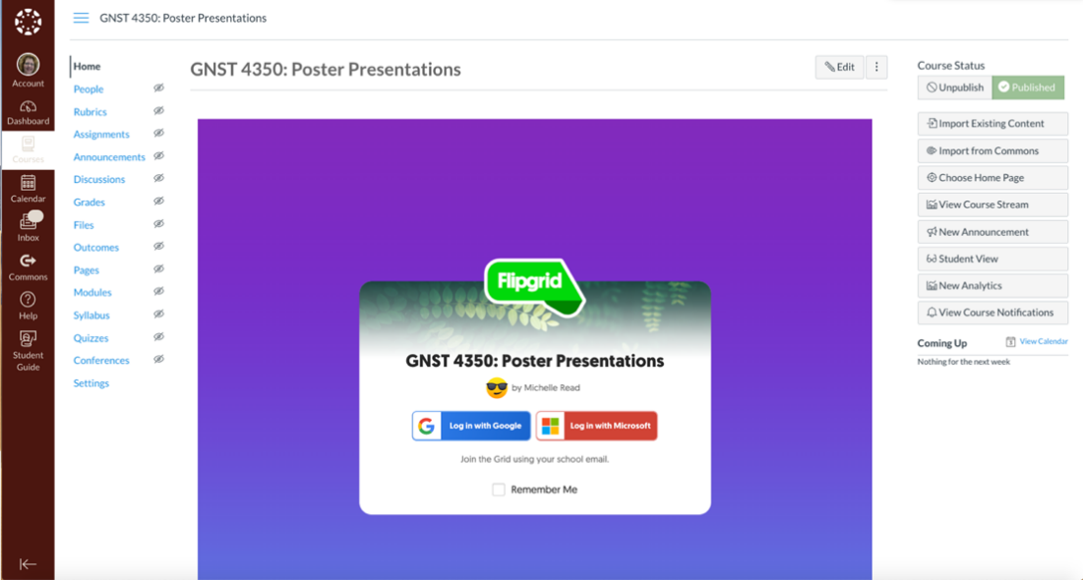

1. 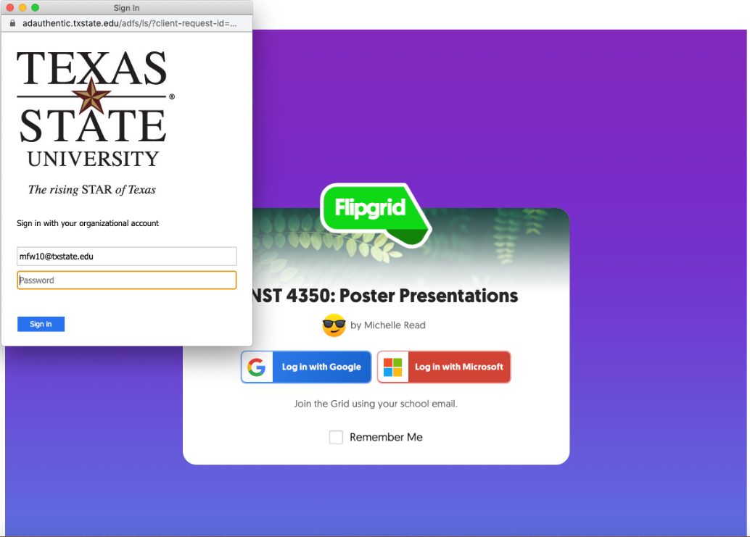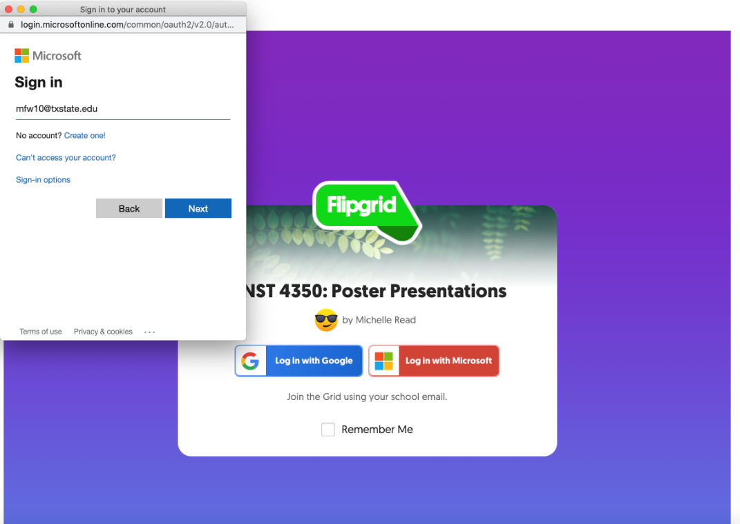Sign in to Flipgrid using your Microsoft Office 365 account (NetID, usual password). You will likely be redirected to the Texas State University SSO login.

1. You should now see the Flipgrid interface.

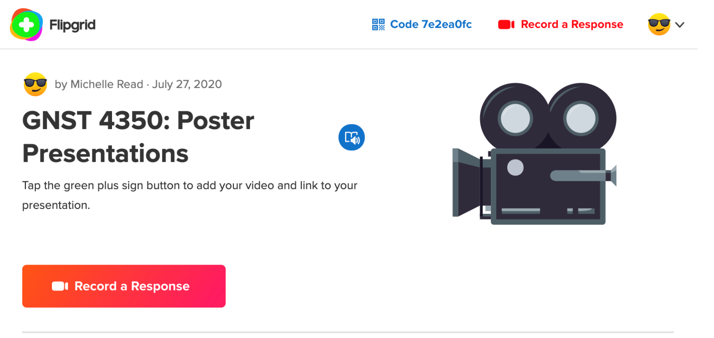

1. Click on “Record a Response” to begin.
2. Use the video wizard to either upload or record your video presentation. Click “Options” to the left of the red record button. \***Note:** The time limit is set up by the instructor.

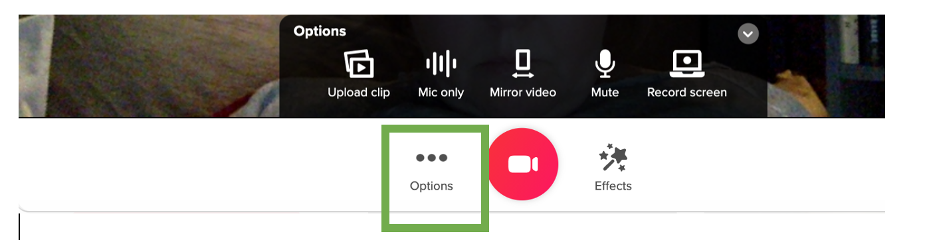

1. As you are recording, you can add and remove sticky notes, images from your computer, drawings, filters, and text boxes, assuming your instructor has allowed this is the setup, by clicking the “Effects” option to the right of the red record button. Press “pause” each time you opt to add or remove one of these elements and then record to continue.

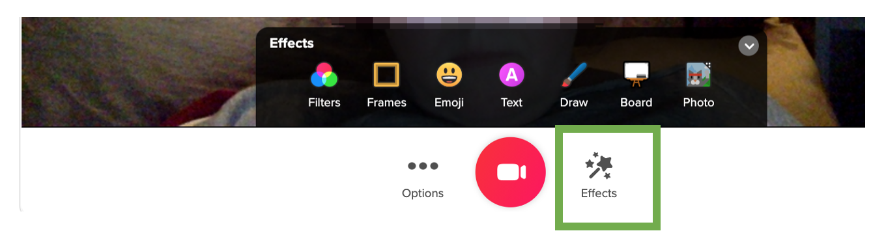

1. Review your recording. Trim or add onto if/as necessary (Assuming this possibility has been turned on by the instructor).
2. Take a selfie to serve as a splash-screen to your video.
3. Finally, on the last screen of the wizard add your name, the title of your presentation, and a link to your presentation file or folder of files in Microsoft 365 (see next section on sharing a document in Microsoft 365). The ability to add links to a presentation video must be turned on by the instructor when setting up the Flipgrid topic.

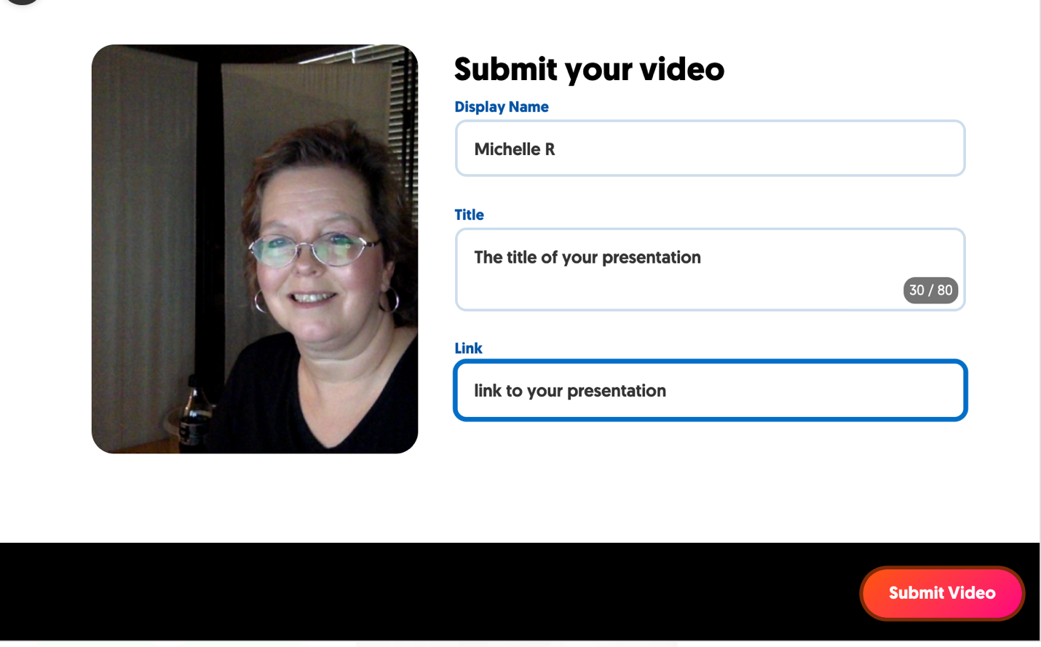

# Alternatives to Traditional Video

If your instructor allows,

1. You can create a whiteboard or blackboard animation: Click “Effects” and “Board” which allows for a split-screen with the author on one side and the board on the other.
2. You can simply record your drawing by clicking “Effects” and “Draw.” The split-screen option is available for this tool as well. This is really good for demonstrating your attempts to solve equations, complete science experiments, or teach drawing skills.
3. Finally, you can create a screen recording with your image in the corner. To select, click the “Options” button to the left of the red record icon. Choose the screen you wish to record.
4. You could even create a silent film if you turned off the audio. J

# Responding to Peers in Flipgrid

1. Once your peers have begun adding their videos, you will see their selfie splash screens appear next to the green plus (+) sign. Simply click on their pictures to watch their video.
2. You can download their slides or other documents (or view their websites) by clicking the document icon in the top right corner.
3. Click the comment spaces below the video to leave a comment in either text or video format, depending on what your instructor has set up.

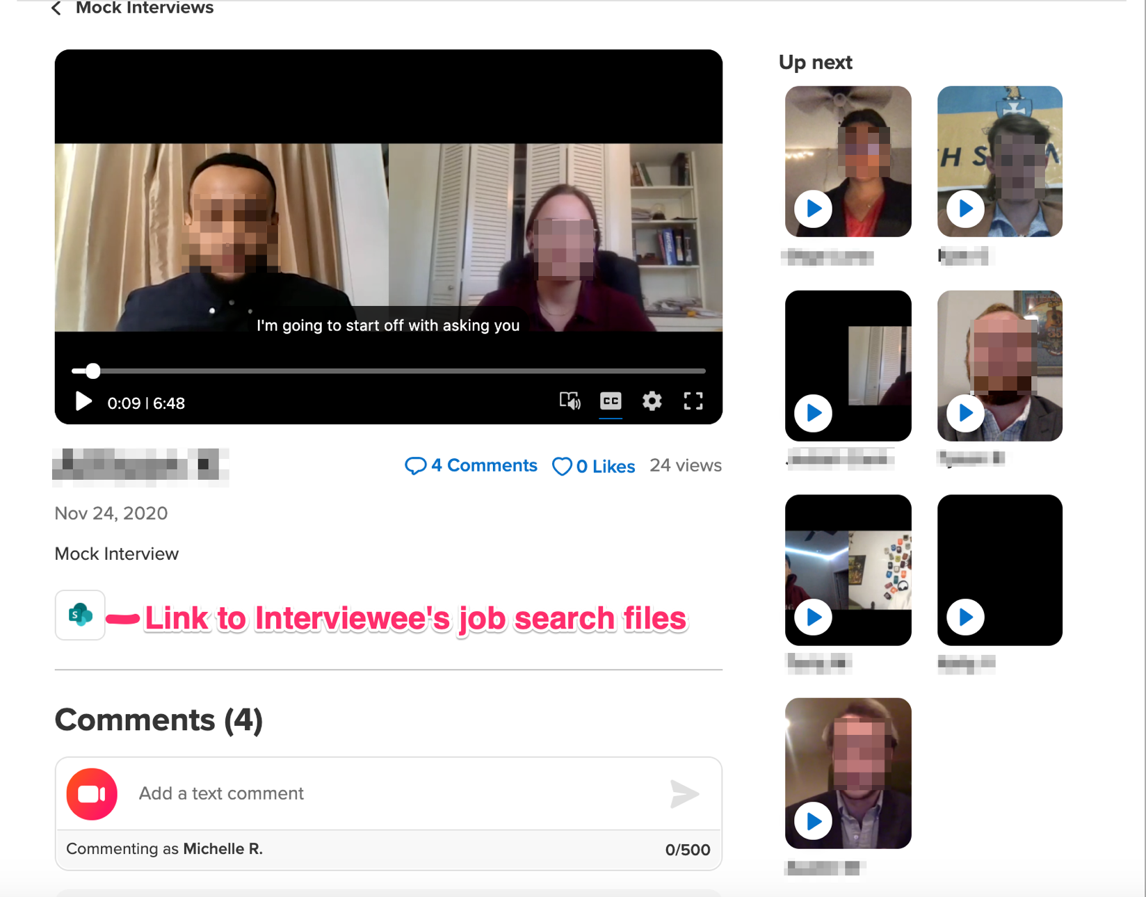

# Sharing a Microsoft 365 Document

1. Upload your files.



1. Share. Click the ellipsis (…) next to the title of your uploaded presentation document. Choose “Share.” On the pop-up “Link settings,” chose “People in Texas State University with the link” and uncheck “Allow editing.” Leave “Block download” set to off. Then click “Apply”

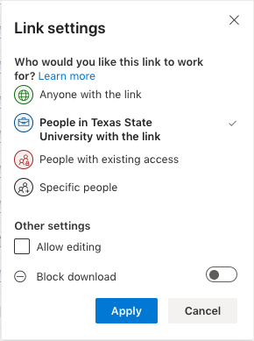

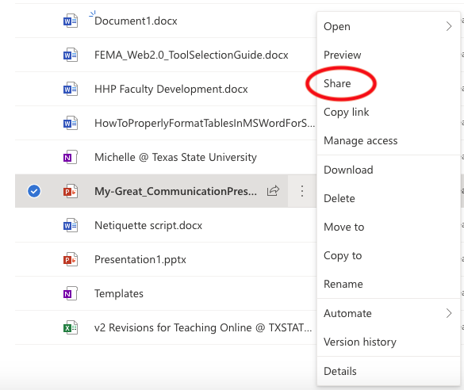

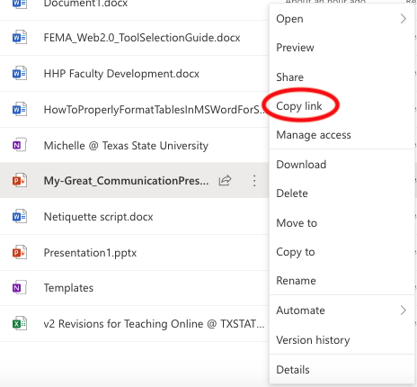

1. Return to the ellipsis (…) next to the title of your uploaded presentation document. Choose “Copy link.” Paste this link in the Flipgrid final slide before submitting, under “Link.”
2. *Note: You can also share an entire folder of files by following the same steps.