Using Gradescope Within Canvas
  - Gradescope Pilot

*Gradescope has been set up for instructor use in the Canvas Gradescope Pilot site.

What you should see
When you open your Canvas course with Gradescope set up, you will see a “Gradescope” button in the course navigation column.

Create an Assignment in Canvas
Title it, “Midterm”, add a description if you like, give it a point value and answer which grading group it belongs to (if applicable) and how you want the grades displayed for students. If this assignment score doesn’t count towards the final grade, be sure to note that too.

Type of Submission - “external tool”, select Gradescope from the list. You can choose to display Gradescope on the same page or force it to open in a new tab.

Fill out the remainder of parameters, such as due date, etc. on the Assignment page and save.

Once saved, you should see the Assignment page content as your students would, with an embedded Gradescope window. Be sure you have published it.

Creating the Assignment in Gradescope:

Once the Canvas Assignment shell has been created, within the Gradescope embedded window, select “Assignments”. Click on the “Add Assignment” button within the embedded Gradescope window”. Choose an “Assignment Type”. For this pilot, choose “Homework/Problem Set”.

- Name your Gradescope assignment identically to the Canvas Assignment title, “Midterm”.

- Select a ‘template’ to upload. A template is like a worksheet with blanks or spaces where students would write the answers. (We talked about the one you uploaded to Canvas and perhaps adding an extra column for notes, so that you are only “grading” the second column since previously students might write in an answer with a notation to check their notes.)

- Choose if the instructor will upload this assignment or if the students will upload this assignment. (We discussed that the instructor would collect physical worksheets and scan them into Gradescope.) *Note – If the instructor uploads the assignment, students will not see the Gradescope embed in the Canvas Assignment. (We talked about adding a note to that affect on the assignment page or hiding the Assignment tab.)

- Decide if you are going to create a ‘rubric’ (or answer key) before submissions or while grading.

- Click “Create Assignment”.

- Create/Edit “Outline”.

Gradescope shows you a preview of your uploaded template. Place a ‘region’ where you put in blanks or spaces for students to write answers on the physical worksheet. You can insert a question with a title and point scale first, or draw regions first and the question list will update.

You can also create a Name or ID Region. This is particularly helpful if you are uploading as the instructor. If students are uploading themselves, Gradescope will pull their name from Canvas.

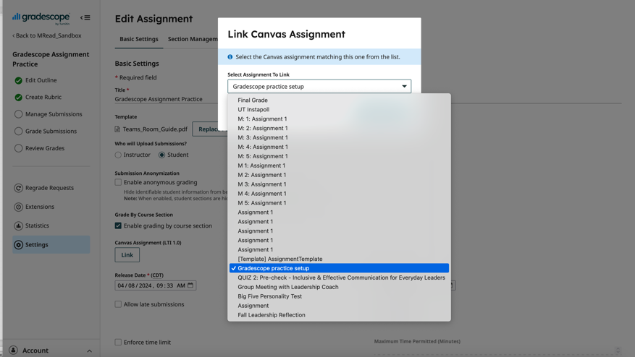
*Note - You can set up a Gradescope Assignment first and then create a matching Canvas space later connect to the Gradescope assignment. However, there must be both a Gradescope and Canvas space for any given assignment for gradebook syncing.
You can link the Gradescope Assignment and Canvas Assignment through Gradescope under “Settings”. Click “Link” and a drop down selection of available assignment to connect to in the Canvas course appear.

Setting up Rubric

If you are coming back to create a rubric after you created and save an assignment, click on the Assignment and choose “Create a Rubric”. Else, the option to create a rubric comes along as part of the assignment creation wizard if you opted to create before submissions.

Under Rubric settings (the gear icon in the top right corner), select if you want points to add up to a score, or if you want points subtracted from a pre-defined total.

Right or Wrong - One “Correct” rubric item has been made for you for each question. “Correct” is the feedback students receive; you just mark the item if the student got it correct. You can create variations of “Correct” if you want to give full or partial credit for variations like spelling and capitalizations. However, it isn’t always easy to pre-determine wrong answers.

In this screenshot below, I’ve added some allowance for misspelling and failure to capitalize.
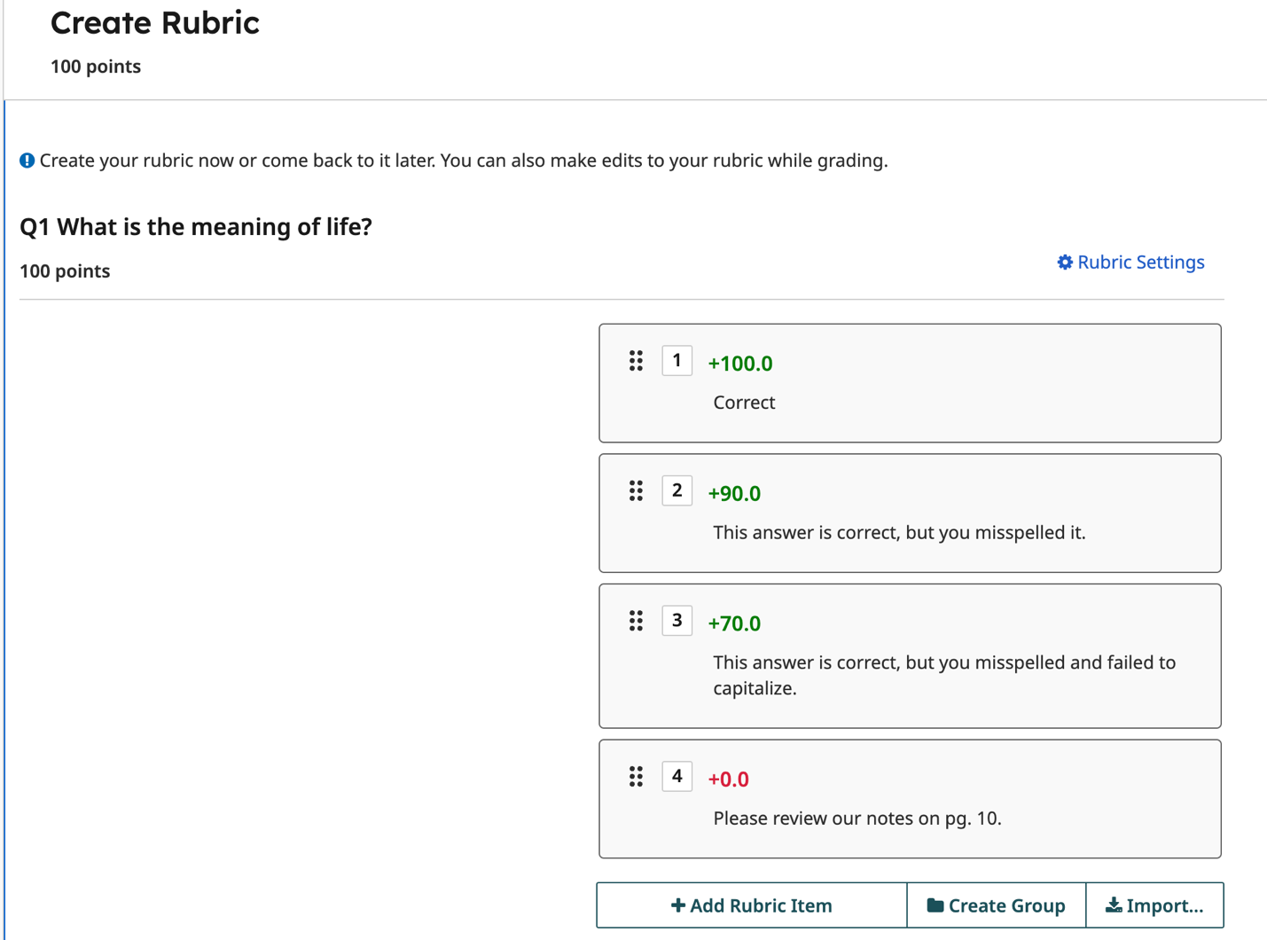

If you don’t care about spelling/capitalization, text or numeric form, just leave the single “Correct” option. Gradescope doesn’t declare it correct, you do.

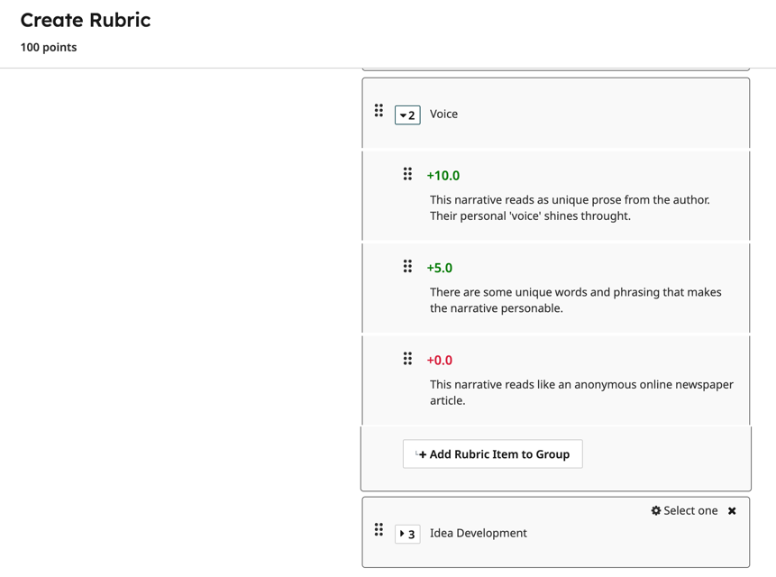
Holistic or Analytic rubrics –
You can create scaled rubrics by adding criterion as a “Group”. For example, if you want to grade a paper based on 3 criteria (Voice, Organization, Idea Development) and a student could earn zerio points, half credit, or full credit, you would create a Rubrice ‘item’ for each and add them to the criteria ‘group’. See screenshot:

Learn more about Gradescope Rubrics at the vendor’s website.

